**System Requirements Specification**

**Mental Health Awareness Application**

**CS 490, Fall, 2020**

**Team Name**:

Helping Hand Awareness

**Team Members:**

Gabi Stoney

Garðar Benediktsson

Harrison Dinius

Jason Hansen

Lizzy Jackson

**Table of Contents**

1 Introduction (Elizabeth Jackson) 4

1.1 System to be Produced: 4

1.2 Applicable Standards: 4

1.3 Definitions, Acronyms, and Abbreviations: 4

2 Product Overview (Elizabeth Jackson) 4

2.1 Assumptions: 4

2.2 Stakeholders: 4

2.3 Event Table: 5

2.4 Use Case Diagram: 5

2.5 Use Case Descriptions: 5

3 Specific Requirements 5

3.1 Functional Requirements: 6

3.2 Interface Requirements: 6

3.3 Physical Environment Requirements: 13

3.4 User and Human Factors Requirements: (Elizibeth Jackson) 13

3.5 Documentation Requirements: (Elizabeth Jackson) 14

3.6 Data Requirements: (Elizabeth Jackson) 14

3.7 Resource Requirements: 15

3.8 Security Requirements: 17

3.9 Quality Assurance Requirements: 19

4 Supporting Material 20

# Introduction

(Elizabeth Jackson)

## System to be Produced:

The goal of this system is to produce an application that will allow for friends, family, and acquaintances to be reminded when to contact others. Oftentimes people will contact various others via text, call, or FaceTime at fluctuating frequencies during varying amounts of time. In times of busy lifestyles and events such as quarantine many forget to contact others. This communication and contact, even through a simple text, can help others from feeling isolated, depressed, or negative. This application will keep track of text messages sent out, and calls participated in. For each contact number there will be a living calculated average, this living average will fluctuate based on the number of times the participant communicates. The user will be reminded when these averages fall to communicate with the person they may have forgotten about or become too busy to remember to talk to.

## Applicable Standards:

The standards identified below are in correlation with those outlined in the Apple Developer Guidelines (see Section 4), and only those relevant to this system are discussed.

* The system will require user permission before collecting data
* The system cannot access/collect user data unless required
  + User data will only ever be seen by the user
  + User data will never be sold/distributed to a third party
  + User data collection will only occur when needed for the express purposes outlined in Section 1.1
* The system is supported by the most current iOS version
* The system uses entirely original code and UI
* The system is tailored towards being an app and not a website
* The development team will follow the Apple Developer Code of Conduct

## Definitions, Acronyms, and Abbreviations:

* Living Average: Average calculated based off of the current amount of times a user has texted or called another within a defined amount of time. Can raise or lower.
* The System: The term used to refer to the product/application.

# Product Overview

(Elizabeth Jackson)

## Assumptions:

* User will install and use app on iOS based device
* User will have at least 5 MB of storage (current project size after initial archive).
* Application will be designed to operate on iPhone running at least iOS 13.7

## Stakeholders:

Customer is considered a top stakeholder due to the positive influence of application on a wide audience and mental health. Customer would be concerned with the proper algorithm to calculate reminders before it becomes too much time.

Users with mental health concerns or communicating with someone who does are considered reasonable stakeholders as the reminders can heavily influence the positive mental state of another.

The National Institute of Mental Health (NIMH) could take interest in the application to use it as an aid to encourage the support of family members and friends with mental health issues/ disorders.

## Event Table:

|  |  |  |  |
| --- | --- | --- | --- |
| Event Name | External Stimuli | External Responses | Internal data and state |
| Living Average Drops for Contact | User has not contacted contact | Application pushes notification for |  |
| User denies access to Texts, calls, FaceTime | User changes settings in app or in settings of device | Application notifies user that access has been denied | Application is unable to reach any contacts and unable to calculate inner circle |
| User changes weighting of any of the methods of communication |  | Application updates user that inner circle ratings have changed (if any) | Program recalculates Living Average based on new weights of text, call, and other |
| Contact blocked by user | User inputs contact number to be blocked |  | Program excludes blocked contacts from calculations and data retrieval |
| Inner circle of contacts is calculated | Contact receive enough trust to change positions | Application updates user that inner circle ratings have changed (if any) | Program calculates trust using collected data |

## Use Case Diagram:

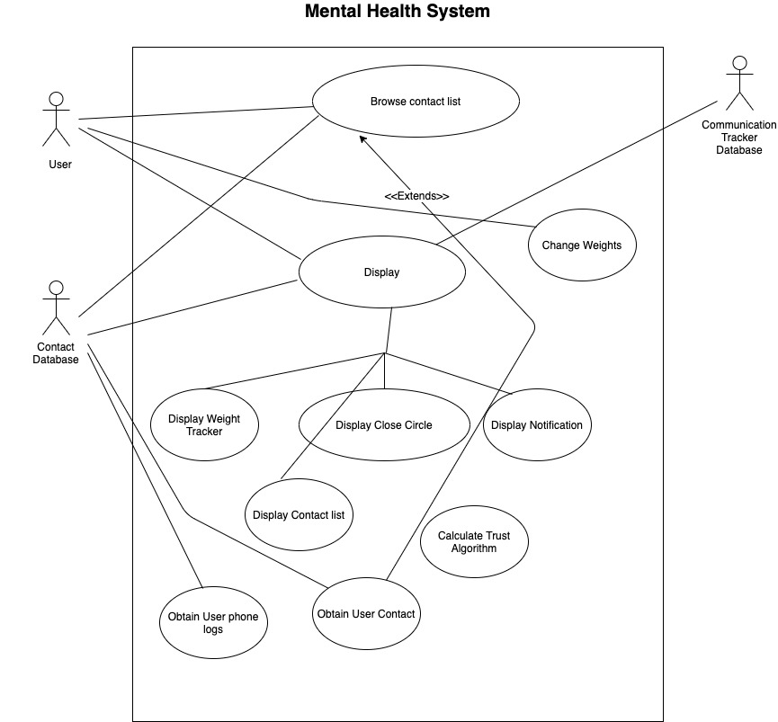

## Use Case Descriptions:

* <Actors - the actors are the User and two databases: Contact Database, Communication Tracker Database
* Processes - The main processes that the system is doing is allowing people to browse, display their information and obtain information.

# Specific Requirements

## Functional Requirements:

|  |
| --- |
| No: 3.1.1 |
| Statement: The system shall allow the user to block certain numbers from being used in the algorithm |
| Source: Product Owner |
| Dependency: 3.2.7 and 3.2.9 |
| Evaluation Method: The system has an option to input a number and that blocks the number from being used in the algorithm |
| Revision History: Garðar, created 9/22 |

## Interface Requirements:

|  |
| --- |
| No: 3.2.1 |
| Statement: The system shall display the names of the user’s innermost circle of friends |
| Source: Product Owner |
| Dependency: 3.2.7 |
| Evaluation Method: The system displays the list of the user’s innermost circle of friends |
| Revision History: Garðar, created 9/22 |

|  |
| --- |
| No: 3.2.2 |
| Statement: The system shall have a home screen (we have to discuss this a bit better, what do we want for our UI) |
| Source: Product Owner |
| Evaluation Method: The app opens up on a home screen |
| Revision History: Garðar, created 9/22 |

|  |
| --- |
| No: 3.2.3 |
| Statement: The system shall notify a user when a ranking has dropped |
| Source: Product Owner |
| Dependency: This requirement will depend on the average line tracker and the database where information is stored. |
| Conflicts: When a user does not input information necessary to create an accurate algorithm judgement. |
| Evaluation Method: The system will send a notification to an IOS user via banner, lock screen, and Notification Center |
| Revision History: Gabrielle Stoney & Jason Hansen Created 09/24 |

|  |
| --- |
| No: 3.2.4 |
| Statement: The system shall send the user a notification survey to rank the quality of communication. |
| Source: Product Owner |
| Dependency: This requirement will depend on the user filling out the survey for each interaction found. |
| Conflicts: When a user does not input information necessary to create an accurate algorithm judgement. |
| Evaluation Method: The system will send a notification after an interaction with a ranking system between 1 and 5 to rate communication experience. The system will then record the response in the database. |
| Revision History: Gabrielle Stoney & Jason Hansen Created 09/24 |

|  |
| --- |
| No: 3.2.5 |
| Statement: The system shall send a notification survey to rate a communication experience as positive or negative. |
| Source: Product Owner |
| Conflicts: There will be a conflict when the user does not complete the survey. |
| Evaluation Method: The system will send a notification after a communication experience with a thumbs up or down to rate communication experience. The system will record the response in the database. |
| Revision History: Gabrielle Stoney & Jason Hansen Created 09/24 |

|  |
| --- |
| No: 3.2.6 |
| Statement: The system shall track the time in between each communication experience. |
| Source: Product Owner |
| Dependency: When a user will fill out an experience survey. |
| Conflicts: There will be a conflict when the user does not complete the survey. |
| Evaluation Method: Time stamps will be inputted into the database for each time a communication experience survey is completed. |
| Revision History: Gabrielle Stoney & Jason Hansen Created 09/24 |

|  |
| --- |
| No: 3.2.7 |
| Statement: The system shall update algorithms after every communication experience survey. |
| Source: Product Owner |
| Dependency: Updated database information |
| Conflicts: If there is any information missing from the user surveys |
| Evaluation Method: The system will send a notification after an algorithm update if their communication levels are deteriorating. |
| Revision History: Gabrielle Stoney & Jason Hansen Created 09/24 |

|  |
| --- |
| No: 3.2.8 |
| Statement: The system shall allow the user to modify the weights within the algorithm. |
| Source: Product Owner |
| Evaluation Method: The system will have a menu for adjusting algorithm weights |
| Revision History: Gabrielle Stoney & Jason Hansen Created 09/24 |

|  |
| --- |
| No: 3.2.9 |
| Statement: The system shall allow a user to input a phone number to ignore. |
| Source: Developer |
| Evaluation Method: The system shall have a textfield available for user input and then display ignored phone numbers in the database. |
| Revision History: Gabrielle Stoney created 09/24 |

|  |
| --- |
| No: 3.2.10 |
| Statement: The system shall modify the algorithm weights, updating the database for each recorded form of communication. |
| Source: Product Owner |
| Evaluation Method: The database will reflect an increment by 1 with a timestamp for each form of communication recorded. |
| Revision History: Gabrielle Stoney created 09/25 |

|  |
| --- |
| No: 3.2.11 |
| Statement: The system shall notify the user when it must request permission to access iOS services. |
| Source: Product Owner |
| Dependency: 3.8.3, 3.9.1 |
| Evaluation Method: The user receives a notification pop-up from the system requesting access to iOS service permissions. |
| Revision History: Harrison Dinius, 9/24, created |

## Physical Environment Requirements:

|  |
| --- |
| No: 3.3.1 |
| Statement: The system shall run on iOS |
| Source: Product Owner |
| Evaluation Method: The system runs on iOS. |
| Revision History: Garðar, created 9/22 |

## User and Human Factors Requirements:

(Elizabeth Jackson)

* Users only need a skill level high enough to use a phone
* App will give directions for first time users
* System will be able to detect when user is not listening to reminders
* Users require no training to be able to use application
* User must be at least 13 years old (in accordance with COPPA)

## Documentation Requirements:

(Elizabeth Jackson)

* Audience should have intermediate skill level with using a mobile Apple device

## Data Requirements:

(Elizabeth Jackson)

* Formula will weight each form of communication from .5 <-> 1.5 and add each time the method is used, constantly updating the average.
  + Ex: Every time a text is sent, a .5/1.0/1.5 will be added to the total and the average for that contact will be recalculated
  + This will create the “Living Average”
* Calculations will be made with a +/- .5 point difference
* Definitions:
  + FOC – Form of Communication
  + DOC – Duration of Communication (text will count as no message sent after an hour)
  + DFLC – Duration from Last Communication
* The trust algorithm goes as follows

Trust0 = FOC*DOC + Impact*Experience – DFLC

Trust = Trust0 + Trust

* + Impact and Experience is based off of user surveys and will impact the trust algorithm only when feedback is given. For the Impact weight, it will either assign a positive or a negative 1 to gauge how an interaction went. The experience weight will change based off how the survey is filled out which is on a scale of 1 to 5. A 1 start rating will give a weight of .2, 2 star rating will give a weight of .4 and so on and so forth.
  + Duration of Last Communication will always be a negative value as time will impact a person’s trust evaluation.
  + Facetime, Calls and Texts will all start with the same wight value of .3 to serve as an equal base for each form of communication. The system will use a counter for each form of communication and will increase this counter every time there is a new entry from the database of these form of communication. The system will then keep a total of all forms of communication and divide each communication counters by the total interaction accounts. This can be see here:
    - TotalCommunication = FTCount + CallCount + TxtCount
    - FTWeight = FTCount/TotalCommunication
    - CallWeight = CallCount/TotalCommunication
    - TxtWeight = TxtCount/TotalCommunication

|  |
| --- |
| No: 3.6.1 |
| Statement: The system shall have a database to store different forms of communication |
| Source: Product Owner |
| Dependency: 3.8.1, 3.7.4 |
| Conflicts: 3.2.8, 3.8.3 |
| Evaluation Method: The database will update all communication contact by a time stamp in the database itself. |
| Revision History: Gabrielle Stoney created 09/24 Harrison, 9/25, added dependency |

## Resource Requirements:

|  |
| --- |
| No: 3.7.1 |
| Statement: The user device shall require a reliable WiFi connection to run the system. |
| Source: Developer |
| Dependency: 3.8.3 |
| Evaluation Method: The system will be able to fulfill the purpose outlined in Section 1 while connected to reliable WiFi. |
| Revision History: Lizzy, 9/22, created Harrison, 9/25, added details |

|  |
| --- |
| No: 3.7.2 |
| Statement: The development team shall make use of Atom for real-time collaboration when coding together. |
| Source: Developer |
| Evaluation Method: The development team has downloaded and used Atom when any two or more developers need to look at/work on code together in real-time. |
| Revision History: Lizzy, 9/22, created Harrison, 9/25, added details |

|  |
| --- |
| No: 3.7.3 |
| Statement: The development team shall make use of Microsoft Teams for video and voice calls, as well as screen sharing. |
| Source: Developer |
| Evaluation Method: The development team has downloaded and used Microsoft Teams whenever a meeting is held and/or screen sharing is necessary. |
| Revision History: Lizzy, 9/22, created Harrison, 9/25, added details |

|  |
| --- |
| No: 3.7.4 |
| Statement: The development team shall have funding for maintaining a Firebase database to store/process data in. |
| Source: Developer |
| Evaluation Method: The development team has the funds to afford renting a database for storing data via Google’s Firebase service. |
| Revision History: Lizzy, 9/24, created Harrison, 9/25, added details |

|  |
| --- |
| No: 3.7.5 |
| Statement: The development team shall use an iOS software development platform (Xcode) to program the system with. |
| Source: Product Owner |
| Evaluation Method: The development team has downloaded and used a software development platform to facilitate coding, testing, and implementation of the system. |
| Revision History: Gabi, 9/24, created Harrison, 9/25, added details |

## Security Requirements:

|  |
| --- |
| No: 3.8.1 |
| Statement: The system shall only access data limited to the contacts, texts, calls, and FaceTime services. |
| Source: Product Owner |
| Evaluation Method: There are no other methods in the system that pull data from any services besides the ones listed in the statement. |
| Revision History: Lizzy, 9/22, created Harrison, 9/24, added details |

|  |
| --- |
| No: 3.8.2 |
| Statement: The system shall not share collected data with anyone other than the user. |
| Source: Product Owner |
| Evaluation Method: All collected data will be kept locally on the users device or be sent securely to Firebase, so nothing other than the user ever views the data. |
| Revision History: Lizzy, 9/22, created Harrison, 9/24, added details |

|  |
| --- |
| No: 3.8.3 |
| Statement: The system shall have it’s service permissions available in iOS settings and in-house for the user to adjust. |
| Source: Platform |
| Evaluation Method: iOS Settings will allow the user to set permissions for contacts, texts, calls, FaceTime, cellular data, notifications, and background app refresh. |
| Revision History: Harrison, 9/24, created |

## Quality Assurance Requirements:

|  |
| --- |
| No: 3.9.1 |
| Statement: The system shall notify users of a request for permissions when access to services is denied. |
| Source: Platform |
| Dependency: 3.8.1 |
| Evaluation Method: Whenever the system attempts to access an iOS service it does not have permission for, it will show the user a notification request for that service. |
| Revision History: Lizzy, 9/22, created Harrison, 9/24, added details |

|  |
| --- |
| No: 3.9.2 |
| Statement: The system shall not take up more than 4 GB of space upon the initial download. |
| Source: Platform (Apple Requirement) |
| Supporting Materials: https://developer.apple.com/news/?id=02122015a |
| Evaluation Method: The app size must not exceed 4 GB for user download. |
| Revision History: Harrison, 9/24, created |

# Supporting Material

Apple Developer Guidelines: <https://developer.apple.com/app-store/review/guidelines/>